**Semi-Annual Narrative Report (SA-NR)**

# **1. Project Details**

GUIDELINES: Please complete the following table with details of the project.

|  |  |
| --- | --- |
| Project Number | <P-4081> |
| Project Title | <GTM Comprehensive Medical and Rehabilitation Project > |
| City/ Country/ Region | <Butajira,SNNPR,Ethiopia > |
|  |  |
| Name of Contractual Partner | <Grarbet Tehadiso Mahber > |
| Other Implementing Partners | <None > |
|  |  |
| Duration of Project | <3 Years> |
| Project Start Date | <01/01/2021 > |
| Project End Date | <31/12/2023> |
| Project Cycle | <January- December> |
|  |  |
| Report Submitted by; |  |
| Name | <Mr.Tehsome Tulu,Mr.Desalegn Amanuel,Prof. Redda TekleHaimanot > |
| Designation | <Deputy Executive Deirector,Program Officer, Executive Director> |
| Email Address | <gblgtm@yahoo.com> |
| Date of Submission | <12/07/2022> |

# **2. Summary of Results Achievements**

GUIDELINES: Insert a qualitative ‘summary’ of the overall progress of the project towards its Result areas. Please focus on the changes (intentional or unintentional) that have come about as a result of implementation of activities. Limit your response to 1 paragraph per result area.

**Result 1: Quality eye care services provided**

Grarbet Tehadiso Mahber (GTM) provided comprehensive and inclusive eye care services through its base centers in Butajira and Batu. By providing quality eye care services, GTM has prevented and restored the sight of patients suffering from common preventable blindness such as Cataract, Refractive Error, and Trachoma. With the help of cbm, GTM Butajira eye care Center is now equipped with the latest Zeiss Lumera 300 operating microscope, Zeiss Visulas YAG laser, and Visalis 100 phaco machine. The acquisition of this modern and high quality equipment has strengthened GTM’s ophthalmological services. Grarbet is extremely grateful to CBM for the exceptional donations.  The mobile eye care team referred patients to both GTM Centers for conditions that could not be treated or managed in the outreach eye care setting. Furthermore, in collaboration with CBM-CO, quality assurance measures for eye care services were implemented to ensure quality outcome of cataract surgeries towards enhanced quality of life of the beneficiaries.

**Result 2: Essential ENT services provided to rural people in central Ethiopia**

There is a severe shortage of quality ear and hearing services in all government primary health care institutions in the rural population. GTM provided critical ENT services in rural central Ethiopia, focusing on Ear and Hearing Care.  . During the reporting period, a good number of beneficiaries were screened and treated at the GTM base center in Butajira for acute and chronic otitis media as well as other common ENT problems. As a result of this, patients were cured from Ear and hearing difficulties to increase their communication skill and quality of their life. To create good access of the EHC services, Furthermore, GTM organized surgical camps for patients who required advanced surgical intervention in close collaboration with Dr. Uta Froeschl of CBM and St. Paul's Hospital Millennium Medical College (SPHMMC). During the surgical camp, residents from SPHMMC received on-job surgical training. COVID-19 safety protocols are still followed when providing Ear and Hearing Care.

**Result 3: Locomotors rehabilitation services provided to persons with disabilities**

GTM provided physiotherapy services together with production and provision of locomotor devices for persons with disability using its center in Butajira. Persons with disability has received medical, surgical as well as locomotive assistive devices as an effort towards rehabilitation. This would contribute for beneficiaries to become independent to participate in the affairs of their communities and become productive. Moreover, raising activities were provided to the community about people who live with physical disabilities.

**Result 4: Medical services provided to patients with Epilepsy in rural central Ethiopia**

One of the leading causes of neurological morbidity in the central rural Ethiopia is Epilepsy. Epilepsy is a condition that causes seizures, temporary episodes that often include twitching and convulsions. These seizures happen when the brain's electrical impulses act abnormally and send erratic signals. Epilepsy can make farming, walking around, or cooking a dangerous activity because they never know when a seizure may strike. Within its center in Butajira, GTM operates at Epilepsy clinic that is run by a qualified Health Officer. Persons with Epilepsy are diagnosed, treated and continuously followed up at the center. Patients can usually supported well through medication and other medical treatments. Consultations and follow up were given through learning how to reduce risks for a seizure through lifestyle changes and being alert on triggers to help them better manage their condition

The Health Officer consults a neurologist (Prof. Redda) on complicated cases. After prolonged treatment, follow up, and consultations, persons with Epilepsy were able to lead improved and productive life.

**5: Provide comprehensive range of LV services**

GTM center in Butajira has a comprehensive eye care service as part of its mission to cater for persons with disability. The low vision unit is now fully integrated with the existing eye care and rehabilitation service. During the reporting period, persons with low vison received LV consultation as well as optical and non-optical assistive devices. The low vision service enabled persons with visual impairments improve their quality of lives. The LV unit is fully equipped with necessary LV examination equipment and devices. Moreover, Non-optical devices such as filter eyeglasses, reading or writing stand and white canes are being produced locally at GTM workshop in Butajira.

**Result 6 Equip and maintain stocks for low vision testing tools, materials, spectacle frames, optical lenses, as well as optical and non-optical devices**

# During the reporting period, GTM requested CBM-CO re-designation of budget earmarked for procurement of low vision devices to strengthen the provision of comprehensive low vision services. This is due to the fact that GTM has sufficient low vision devices (optical and non-optical) in GTM’s store. The request has been approved by CBM,CO, and the project team will begin providing low vision services in accordance with the activities outlined in the proposal. The designated purpose /activities mainly focuses on providing LV services at selected primary schools and communities in the targeted Woredas in Selti and Gurague Zones .

# **3. Narrative Reporting on Activity Implementation**

3.1 GUIDELINES: Which activities were planned to be implemented in the first six months (Q1 and Q2)? Please list down the Activity Name and Number only.

**List of activities implemented during the reporting period**

**Result 01: Quality eye care services provided**

* 1. Eye patients screened and treated
  2. Active Trachoma cases treated with TTC
  3. Lid surgeries performed
  4. Cataract surgeries performed
  5. Adults and children refracted
  6. Adults and children educated

**Result 02: Essential ENT services provided to rural people in central Ethiopia**

* 1. Patients screened and treated for ENT problems
  2. Patients treated for ear infection
  3. Removal of foreign body for adults and children
  4. Audiometry performed for persons with Hard of Hearing
  5. ENT surgeries performed

**Result 03: Locomotor rehabilitation services provided to persons with disabilities**

* 1. Persons with disability screened
  2. Persons rendered with physiotherapy service
  3. Patients treated with PoP for Club foot
  4. Appliances and devices produced and distributed
  5. Appliances and devices maintained

**Result 04: Medical services provided to patients with Epilepsy in rural central in rural central Ethiopia**

* 1. Newly enrolled patients with Epilepsy
  2. Epileptic patients will be followed up

**Result 05** **Provide comprehensive range of LV services**

5.1. Low vision screening of children and adults

5.2 Provision of appropriate LV devices and materials to enable persons with low vision to benefit from their remaining vision

5.3 Provide on-going training and counseling to low vision patients and care takers

5.4 Regular follow-up of patients who acquired low vision devices

5.5 Awareness raising on low vision about the availability of LV services at Grarbet Hospital

**Result 6 Equip and maintain stocks for low vision testing tools, materials, spectacle frames, optical lenses, as well as optical and non-optical devices**

3.2 GUIDELINES: Using the list above, please report on the activities implemented during the quarter. Describe if any targets were achieved, or explain any variance in achieved versus planned activities in the quarter. Explain who the main beneficiaries were.

**Activities implemented during the reporting period**

**Result 01: Quality eye care services provided**

* 1. **Eye patients screened and treated**

23,499 adults (Male: 12,656 and Females: 10,793) and 4,430 children (Boys: 2,334 and Girls: 2,096) received comprehensive eye care services using GTM base Centers. The eye examination are provided by GTM’s senior ophthalmologist, cataract surgeons, ophthalmic nurses and optometrists. Emphasis was given to the quality of eye care service rendered to the patients from all corners of the country. In this regard, morning meeting are being held every morning to evaluate the quality of services and corrective measures for incidents that occasionally occurs were taken. The outreach eye care teams also refer patients with low vision and those needing advanced interventions to both GTM Centers . The low vision patients are referred to Butajia Center while those needing advanced interventions are referred to both Butajira and Batu GTM Centers. The low vision patients are referred to Butajira Center while those needing advanced interventions are referred to both Butajira and Batu GTM Centers.

* 1. **Active Trachoma cases treated with TTC**
  2. **Lid surgeries performed**

Among patients screened for eye problems, 4,993 adults (Male: 2,664 and Female: 2,329) and 1,100 children (Boys: 580 and Girls: 520) were diagnosed as having active trachoma and were treated with TTC eye ointment. Trachoma is still a major cause of eye health problem and accounts for the 21.8% of the patients presenting to both GTM centers during the reporting period. As a part of GTM trachoma elimination program, patients presenting with inward growth of eyelashes (TT) received surgery for entropion trachomatous trichiasis (TT). Hence, 286 lid surgeries were performed for 286 adults (Male: 95 and Female: 191).

* 1. **Cataract surgeries performed**

GTM provides cataract surgery to beneficiaries in the central rural Ethiopia. During the reporting period a total of 1,195 adults (Male: 574 and Female: 621) and four children (Boys: 2 and Girls: 2) were operated for blinding cataract. Emphasis is given to preparation and outcome of patients operated for cataract. All of the cataract operation were performed after proper biometry measurements, using Auto-keratometer and the latest A-B scanner, were conducted by GTM’s optometrist. In this regard, mandatory CSOM were also undertaken to monitor and assesses the quality of cataract surgery. This ensure successful visual outcomes and the results are encouraging. In addition to the routine service delivery, GTM is involved in academic training in relation to Eye care. Ophthalmology Residents from St. Paul’s Hospital Millennium Medical College (SPHMMC) are attached at GTM center in Butajira for a hands-on training. Each resident stays for a 6 weeks. Feedback from the residents and SPHMMC Ophthalmological Department has been positive and encouraging. The residents have satisfied with the training they have received. They were able to perform good number of surgeries under the GTM ophthalmologist guidance. They were also exposed to different ocular cases which they have only thought in theory.

* 1. **Adults and children refracted**

Refractive errors is one of the major cause of preventable visual impairment. During the reporting period GTM optometrist refracted a total of 4,514 adults (Male: 2,761 and Female: 1,757) and 283 children (Boys: 137 and Girls: 146) for refractive errors. Low cost and good quality corrective eyeglasses were also produced and dispensed for beneficiaries needing glasses. 2,663 adults (Male: 1,842 and Female: 821) and 143 children (Boys: 66 and Girls: 77) received spectacles to correct refractive errors.

* 1. **Adults and children educated**

**Result 02: Essential ENT services provided to rural people in central Ethiopia**

* 1. Patients screened and treated for ENT problems
  2. Patients treated for ear infection
  3. Removal of foreign body for adults and children
  4. Audiometry performed for persons with Hard of Hearing
  5. ENT surgeries performed

GTM continued to provide advanced ENT care services or the community in its operational and adjacent districts through its walk-in clinic at Butajira and using routine surgical camps with Dr. Uta Froeschl of CBM.

During the reporting period, 5,661 adults (Male: 2,979 and Female: 2,682) and 2,412 children (Boys: 1,362 and Girls: 1,050) were screened and treated for ENT problems. Among these, 1,399 adults (Male: 738 and Female: 661) and 1,318 children (Boys: 764 and Girls: 554) were treated for ear infections at the center.

GTM renders audiometry for patients presenting to its center with hard of hearing and recurrent ear infection. During the reporting period, audiometry was performed for 195 adults (Male: 114and Female: 81) and 46 children (Male: 27 and Female: 19). Although there are a lot of patients with hearing loss who could benefit from the hearing aids, high cost and shortage of hearing aids has become a major challenge for providing this service.

GTM held two surgical camps in collaboration with Dr. Uta Froeschl as part of the collaboration between GTM, SPHMMC and CBM. During the surgical camps, 60 adults (Male: 32 and Female: 28) were operated for major surgical ear problems like tympanoplasties,keloid excision and deep foreign body removal. ENT residents from SPHMMC joined the surgical team for a hands-on training. Covid-19 test were done for all patients prior to the surgery.

**Result 03: Locomotor rehabilitation services provided to persons with disabilities**

* 1. **Persons with disability screened**
  2. **Persons rendered with physiotherapy service**

Providing locomotor and rehabilitation services to target beneficiaries was an essential project activity of GTM during the six months. Using GTM's base center in Butajira, a total of 944 adults (Male: 523, Female: 421) and 391 children (Boys: 269, Girls: 122) were screened for physical disability. GTM physiotherapist and his assistants provided physiotherapy services for 4,024 adult clients and 747 children clients (boys: 511, girls: 236) on active follow up.

* 1. **Patients treated with PoP for Club foot**

Patients with clubfoot are treated at GTM rehabilitation unit using the Ponseti technique. In this regard, the rehabilitation team applied PoP for 252 clients needing the service. The service was closely supported by Hope Walks.

* 1. **Appliances and devices produced and distributed**
  2. **Appliances and devices maintained**

Mobility appliances namely, crutches, braces, orthopedic shoes, Ankle-foot orthoses (AFO) and Knee-Ankle-Foot orthoses (KAFO) are produced inside GTM orthopedic workshop for persons with physical disability. This will enable persons with physical disability to be self-sufficient concerning mobility and become productive. In the reporting period, Appliances and locomotive devices were distributed for 418 adults (Male: 285, Female: 133) and 86 children (Male: 52, Female: 34). Moreover, maintenance of appliances was done for a total of 305 adults (Male: 128, Female: 180) and 51 children (Male: 26, Female: 25). Furthermore, GTM’s orthopedic surgeon performed clubfoot surgical procedure for 24 children [Boys 22, Girls: 2] and other surgeries related to physical impairment for two females.

**Result 04: Medical services provided to patients with Epilepsy in rural central in rural central Ethiopia**

**4.1 Newly enrolled patients with Epilepsy**

**4.2 Epileptic patients will be followed up**

Care and treatment for persons with epilepsy was also one of GTM's central activities during the reporting period. 139 adults (Male: 79 and Female: 60) and 140 children (Male: 53 and Female: 57) were newly enrolled to the epilepsy clinic. Additionally, 3,719 adults (Male: 2,071 and Female: 1,648) and 1,374 children (Boys: 868 and Children: 506) visited the epilepsy clinic for an active follow up. The seasonal availability and high price of medicines for the treatment of Epilepsy continued to be a major challenge for the reporting period.

**Result 05** **Provide comprehensive range of LV services**

5.1. Low vision screening of children and adults

The optometrist with low vision experience provides low vision examination, dispense low vision aids and counsel persons with low vision to cope with the loss of vision and to enable them maintain productivity A total of 121 adults [Male: 76 and Female: 45] and 3 children [Boys: 2 and Girl: 1] were screened for LV in the reporting period. All of the patients were referred to vision rehabilitation services by GTM ophthalmologist to insure that the medical aspects of the condition is being managed. The following intervention program were followed to rehabilitate person with visual impairment.

1. Provision of tools that substitutes for lost function such as magnifiers, telescopes and other non-optical devices.

2. Making environmental adaptions to facilitate visual task such as improving the surrounding with bright light and contrast objects.

**5.2 Provision of appropriate LV devices and materials to enable persons with low vision to benefit from their remaining vision**

**5.3 Provide on-going training and counseling to low vision patients and care takers**

During the reporting period, a total of 56 adults [Male: 39 and Female: 17] and 2 children [Boy: 1 and Girls: 1] were provided with optical (32) and non-optical (26) LV devices. It is also important to check the patients understands what tasks the devices designed and prescribed to be used for. In this regard, the beneficiaries with their care takers were trained on how to use the LV devices and improve their productivity. Most of the patients benefited from the training sessions which allow them to make the most of their low vision aids in daily life. A total of 194 adults and 5 children [Boys: 3 and Girls: 2] provided counseling and training.

**5.4 Regular follow-up of patients who acquired low vision devices**

Following up low vision patients after they have received low vision examination is critical. This will allows the examiner to ensure the devices dispensed are appropriate. During the reporting period, a total of 13 person with low vision were followed after acquiring LV devices. The follow-up were held through telephone and also by bringing the patients back to the Center if needed.

**5.5 Awareness raising on low vision about the availability of LV services at Grarbet Hospital**

The health education session is now embedded to the ongoing health education session, which is provided every morning at GTM Butajira Center. Similarly, the outreach eye care teams also engaged on the awareness raising activity to increase the uptake of low vision service. During the reporting period, 16,756 adults (Male: 8994 and Female: 7762) and 3252 children (Male: 1669 and Female: 1556) attended the health education sessions.

# **4. Challenges and Lessons Learned**

GUIDELINES: Please complete the table below with challenges that were encountered during the reporting period and the lessons learned. Include any solution that you plan to implement in the next reporting period. (If you have used the Status Column in the Indicator Tracking Sheet (Column K) to report Challenges against specific indicators, make sure you elaborate on the challenge in the table below)

|  |  |
| --- | --- |
| Challenge | Lessons learned / solutions |
| <Ever increasing cost of medicines in the local market> | <GTM used its limited resources to cover for the additional cost of medicines. Furthermore, GTM is soliciting extra funds to cover for the additional costs of medicines and medical supplies> |
| <Unavailability of hearing aids > | <Besides the ENT screening and treatment of patients with ENT problems, GTM had been actively involved in providing hearing aids or assistive listening devices to improve the residual hearing threshold of patients with hard of hearing. However, the high cost and scarcity of hearing aids halted the services we had been providing to the providing to the poor and marginalized communities of central rural Ethiopia. GTM has been advocating for the re-purposing of used hearing aids, donated by charities, for patients who do not have other options. In recent years, the importation of used hearing aids has been prohibited. GTM is looking for ways to address this critical issue with relevant authorities. > |

# **5. Changes in Implementation Plan and Personnel (if applicable)**

GUIDELINES: Please use the space below to specify any changes to (I) the implementation plan (strategies, timelines, targets or key results; also specify if any approval for changes has been sought from CBM), (II) any changes in personnel at the organization’s senior management level, (III) key positions related to the project implementation.

Budget for overseas procurement of LV stocks and devices has been re-allocated to strengthen the LV services because there is adequate stock of LV devices for 2022. Hence, a budget amount of ETB 1,035,962.00 is approved as budget re-allocation to LV services.

**6. Risk Update (If applicable)**

GUIDELINES: Have any of the risks identified during the project design materialized or changed?

No update to the risks and assumptions.

**7. Activity Forecast**

GUIDELINES: Which activities are planned to be implemented in the next 6 months (Q3 and Q4)? Please list down the Activity Name and Number only.

**List of activities planned to be implemented in the next 6 months**

Result 01: Quality eye care services provided

1.1 Eye patients screened and treated

1.2 Active Trachoma cases treated with TTC

1.3 Lid surgeries performed

1.4 Cataract surgeries performed

1.5 Adults and children refracted

1.6 Adults and children educated

1.7 Safeguarding training for project staff

Result 02: Essential ENT services provided to rural people in central Ethiopia

2.1 Patients screened and treated for ENT problems

2.2 Patients treated for ear infection

2.3 Removal of foreign body for adults and children

2.4 Audiometry performed for persons with Hard of Hearing

2.5 ENT surgeries performed

Result 03: Locomotor rehabilitation services provided to persons with disabilities

3.1 Persons with disability screened

3.2 Persons rendered with physiotherapy service

3.3 Patients treated with PoP for clubfoot

3.4 Appliances and devices produced and distributed

3.5 Appliances and devices maintained

Result 04: Medical services provided to patients with Epilepsy in rural central in rural central Ethiopia

4.1 Newly enrolled patients with Epilepsy

4.2 Epileptic patients will be treated and followed up

Result 05 Provide comprehensive range of LV services

5.1. Low vision screening of children and adults

5.2 Provision of appropriate LV devices and materials to enable persons with low vision to benefit from their remaining vision

5.3 Provide on-going training and counseling to low vision patients and care takers

5.4 Regular follow-up of patients who acquired low vision devices

5.5 Awareness raising on low vision about the availability of LV services at GRARBET Hospital

5.6 Train teachers on how to identify children with key low vision and on classroom management

5.7 Organize experience-sharing visit for senior optometrist of GTM to Kenya low vision program and Kikuyu low vision Center

**Re-designated project activities**: The procurement of low vision items (Activity 06.01) to low vision screening of children and adults (Activity 05.01)

* Determine the prevalence of low vision among students attending in selected 20 primary schools in Meskan District.
* Preparing large, clear letters for all the signs in each department of GTM Center. Ensure there is good overall illumination and avoid creating glare.
* In the waiting area of GTM Center, prepare brightly colored chairs, or paint them in a contrasting color compared to the walls and floor.
* Provide low vision training for special education teachers on the importance of early referral to the an eye center, how to identify children with low vision ,on how to work with children with low vision, on how to work with children with low vision as well as on the classroom management.
* Train community-based key informants to identify all children with low vision loss in their community and link to GTM center those children who do not attend schools.
* Conduct awareness raising campaigns in GTM’s catchment areas through megaphone mounted on a vehicle, poster and leaflets to increase the uptake of low vision service at GTM Butajira
* Provide on-going Home to Home follow up to ensure that children and adults with low vision are using the prescribed low vision devices and flows the recommendation provided by the Optometrist with low vision experience.

**Photos**

GUIDELINES: Please use the space below to paste any photos, with captions, news items etc. related to the project. Please ensure that written consent has been obtained from all identifiable people in the photos.

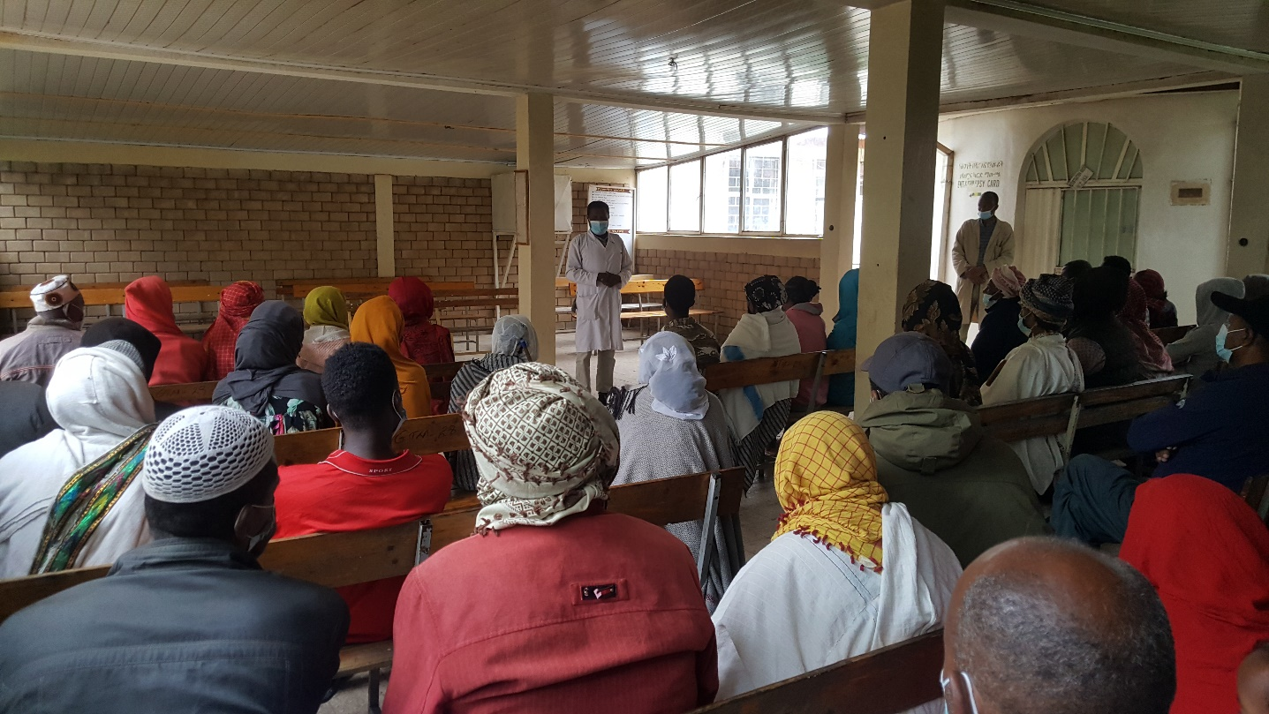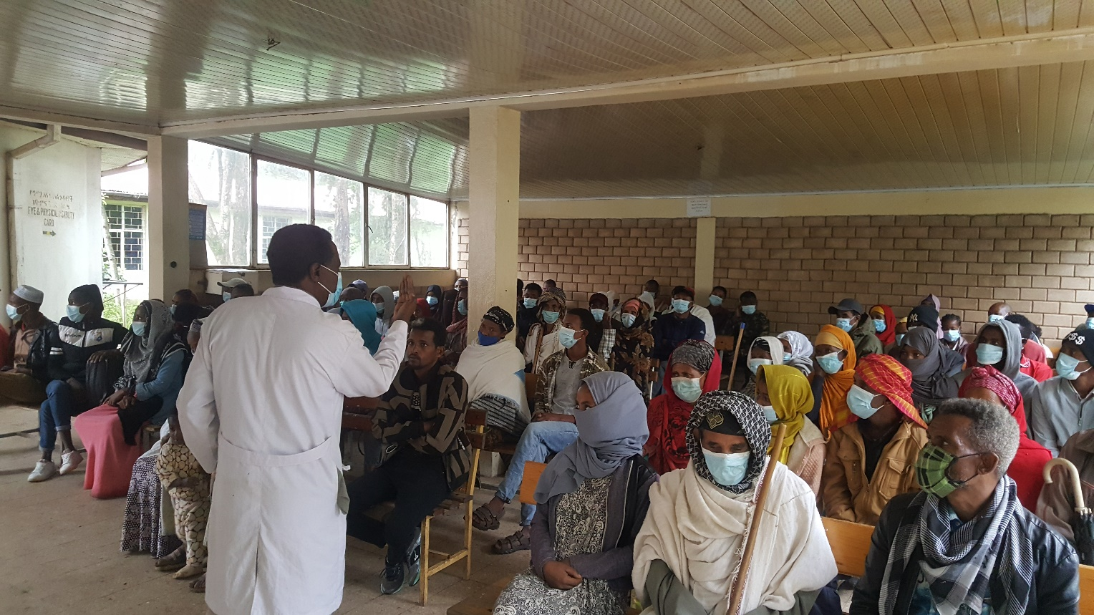

Fig 1. Moring health education on all the intervention areas at GTM Butajira Center

# **9. Comments from CBM Country Office[1]**

GUIDELINES: **(Only to be filled by the Country Office)** Please use the space below to briefly comment on the quality of project implementation and reporting, and describe whether the project is on track and on schedule. If a monitoring visit was conducted during the last 2 quarters, what were the main findings and recommendations?

GTM seems to have strong leadership skills such as being able to motivate their team and drive them to maximum performance so that they can achieve their objectives. The project objective is realized into five result areas: 1. Quality eye care services provided 2. Result 2: Essential ENT services provided to rural people in central Ethiopia, Result 3: Locomotors rehabilitation services provided to persons with disabilities, Result 4: Medical services provided to patients with Epilepsy in rural central Ethiopia, and 5: Provide comprehensive range of LV services. Based on the comparative analysis between the actual target value and the data value provided in each result area, it is learnt that the partners has been making a good progress in responding to the affected populations from mainly the rural communities including the urban communities in all the intervention areas. Provision of quality eye care services has been in a good progress thanks to the softening of the impact of covid-19 pandemic, which used to restrict travel of people. Besides, project planned activity implementation and budget utilization is in a good shape. Most of the activities were implemented under budget within schedule keeping the scope of the project. Quality of services has not ben analyzed and it would be hard to tell if patient satisfaction of services have been ensured. However, financial, management has a persisting issue where the partner seemed to mix salary payments with activity implementation, and making it unclear to what proportion of the budget actually went to salary payment, and what amount to activity implementation. Furthermore, it would be difficult to ensure if the result areas were not compromised. The partner has continued to be compliant with CBM’s timely financial and programme report delivery. Feedback and comment on the reports have been given, and they are revised accordingly. With consistent follow up and remote monitoring from CO relevant Officer, the partner would perform better towards meeting the objective of the project.

1. If there is no Country Office, then the Regional Office/IAA/TU is invited to share their comments as per the arrangement.